1. Create some test-case scripts at the link: *https://www.seleniumeasy.com/test/basic-first-form-demo.html*

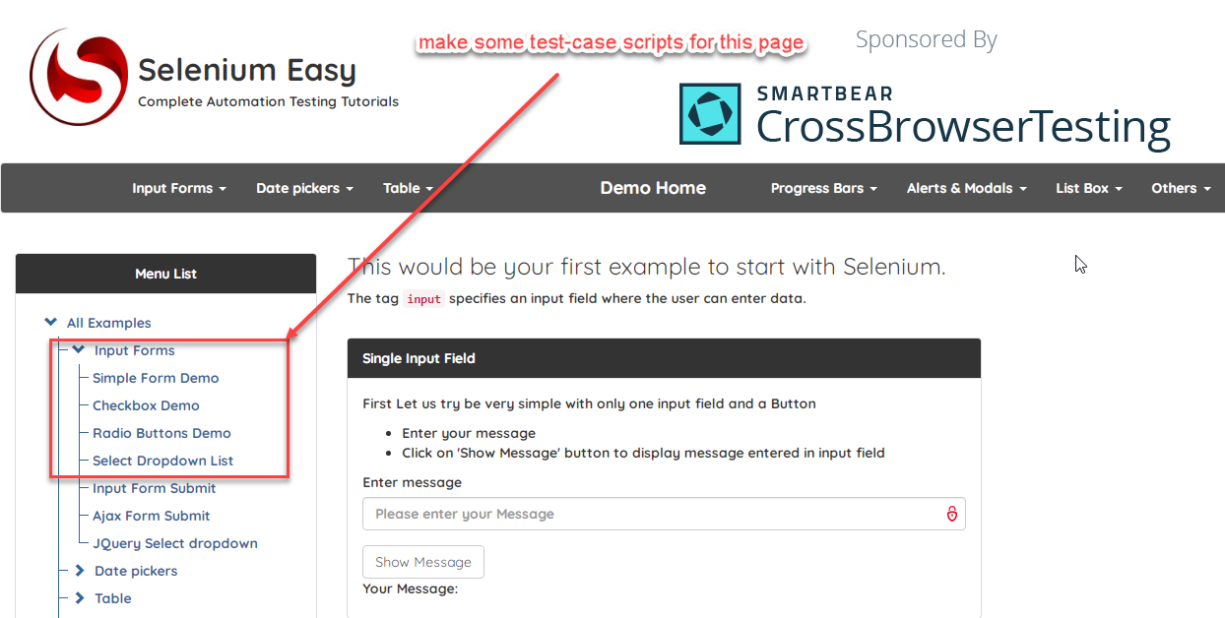

1. Class organization:

* **“pages” package:** include classes which perform Web elements’ operations of pages. For example: “SingleFormDemo” class has methods corresponding to the behaviors of the “Single Form Demo” page.
* **“pageUIElements” package:** include classes which perform Web elements’ xPath data of pages. For example: “SingleFormDemoUI” class has xPath data for Web elements of the “Single Form Demo” page.
* **“dataProviders” package:** has data-provider for each test-case. For example: “InputFormsDataProvider” class has a method to get data from an excel file and give the data to the corresponding test-case.
* **“testCases” package:** include classes which perform test-case scrips.

